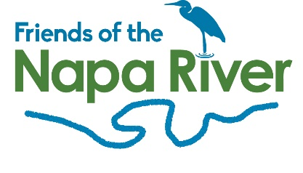

Membership Form
Yes, I want to support Friends of the Napa River!
I am committed to responsibly protect, restore, develop and celebrate the Napa River and its watershed as a vital and precious natural and community resource of the entire Napa Valley.

Name

Address:

Phone:

E-mail:

My special interests in the river are:

I would like to volunteer for:

Select your membership level:
$1,000 and above – Best Friend
$500-$999 – Close Friend
$100-$500 – Family Friend
$50- $99 – Friend
$25-$50 – Student/Senior Friend
Three ways to donate:
Donate by credit card:
Amount $_________ Card number:_______________________ Expiration date: ____________
Or, Donate by check. Please make check payable to Friends of the Napa River and mail it to:
Friends of the Napa River
P.O. Box 537
Napa, CA 94559
You can also donate online via PayPal at www.fonr.org using the DONATE link.

